Biceps:
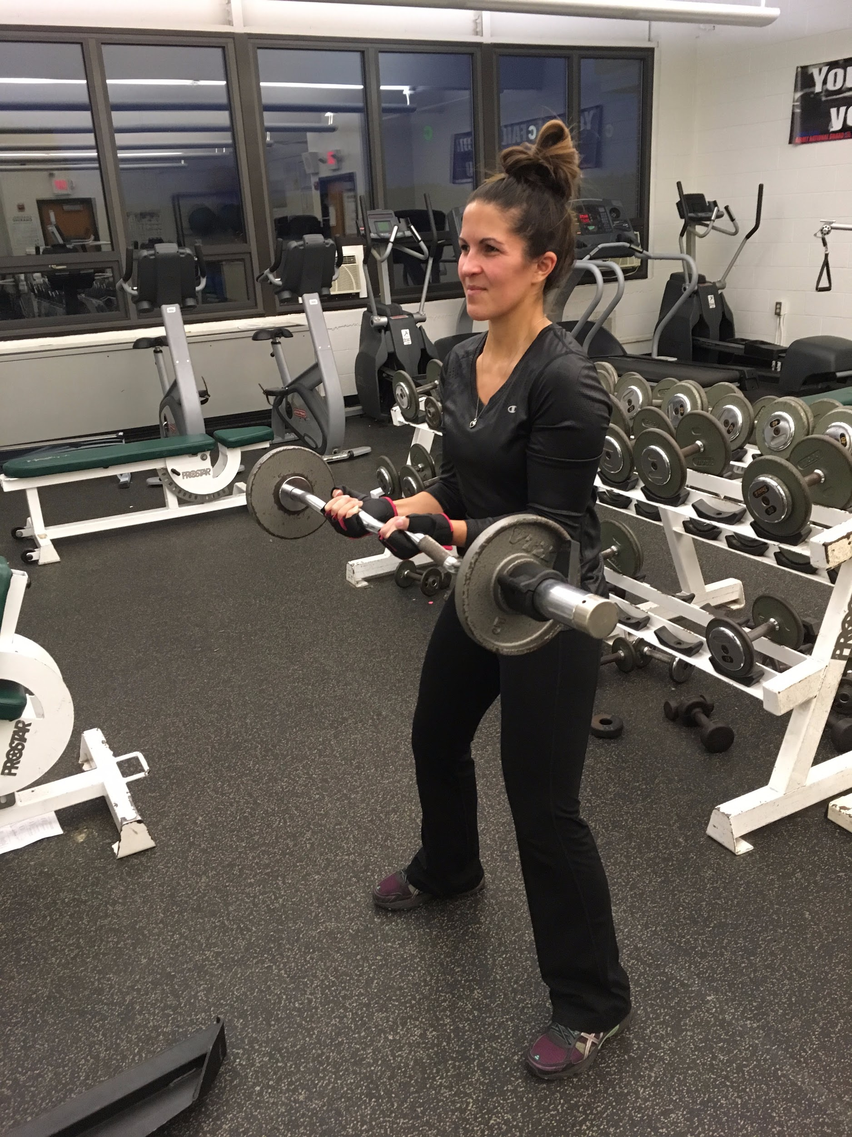 or 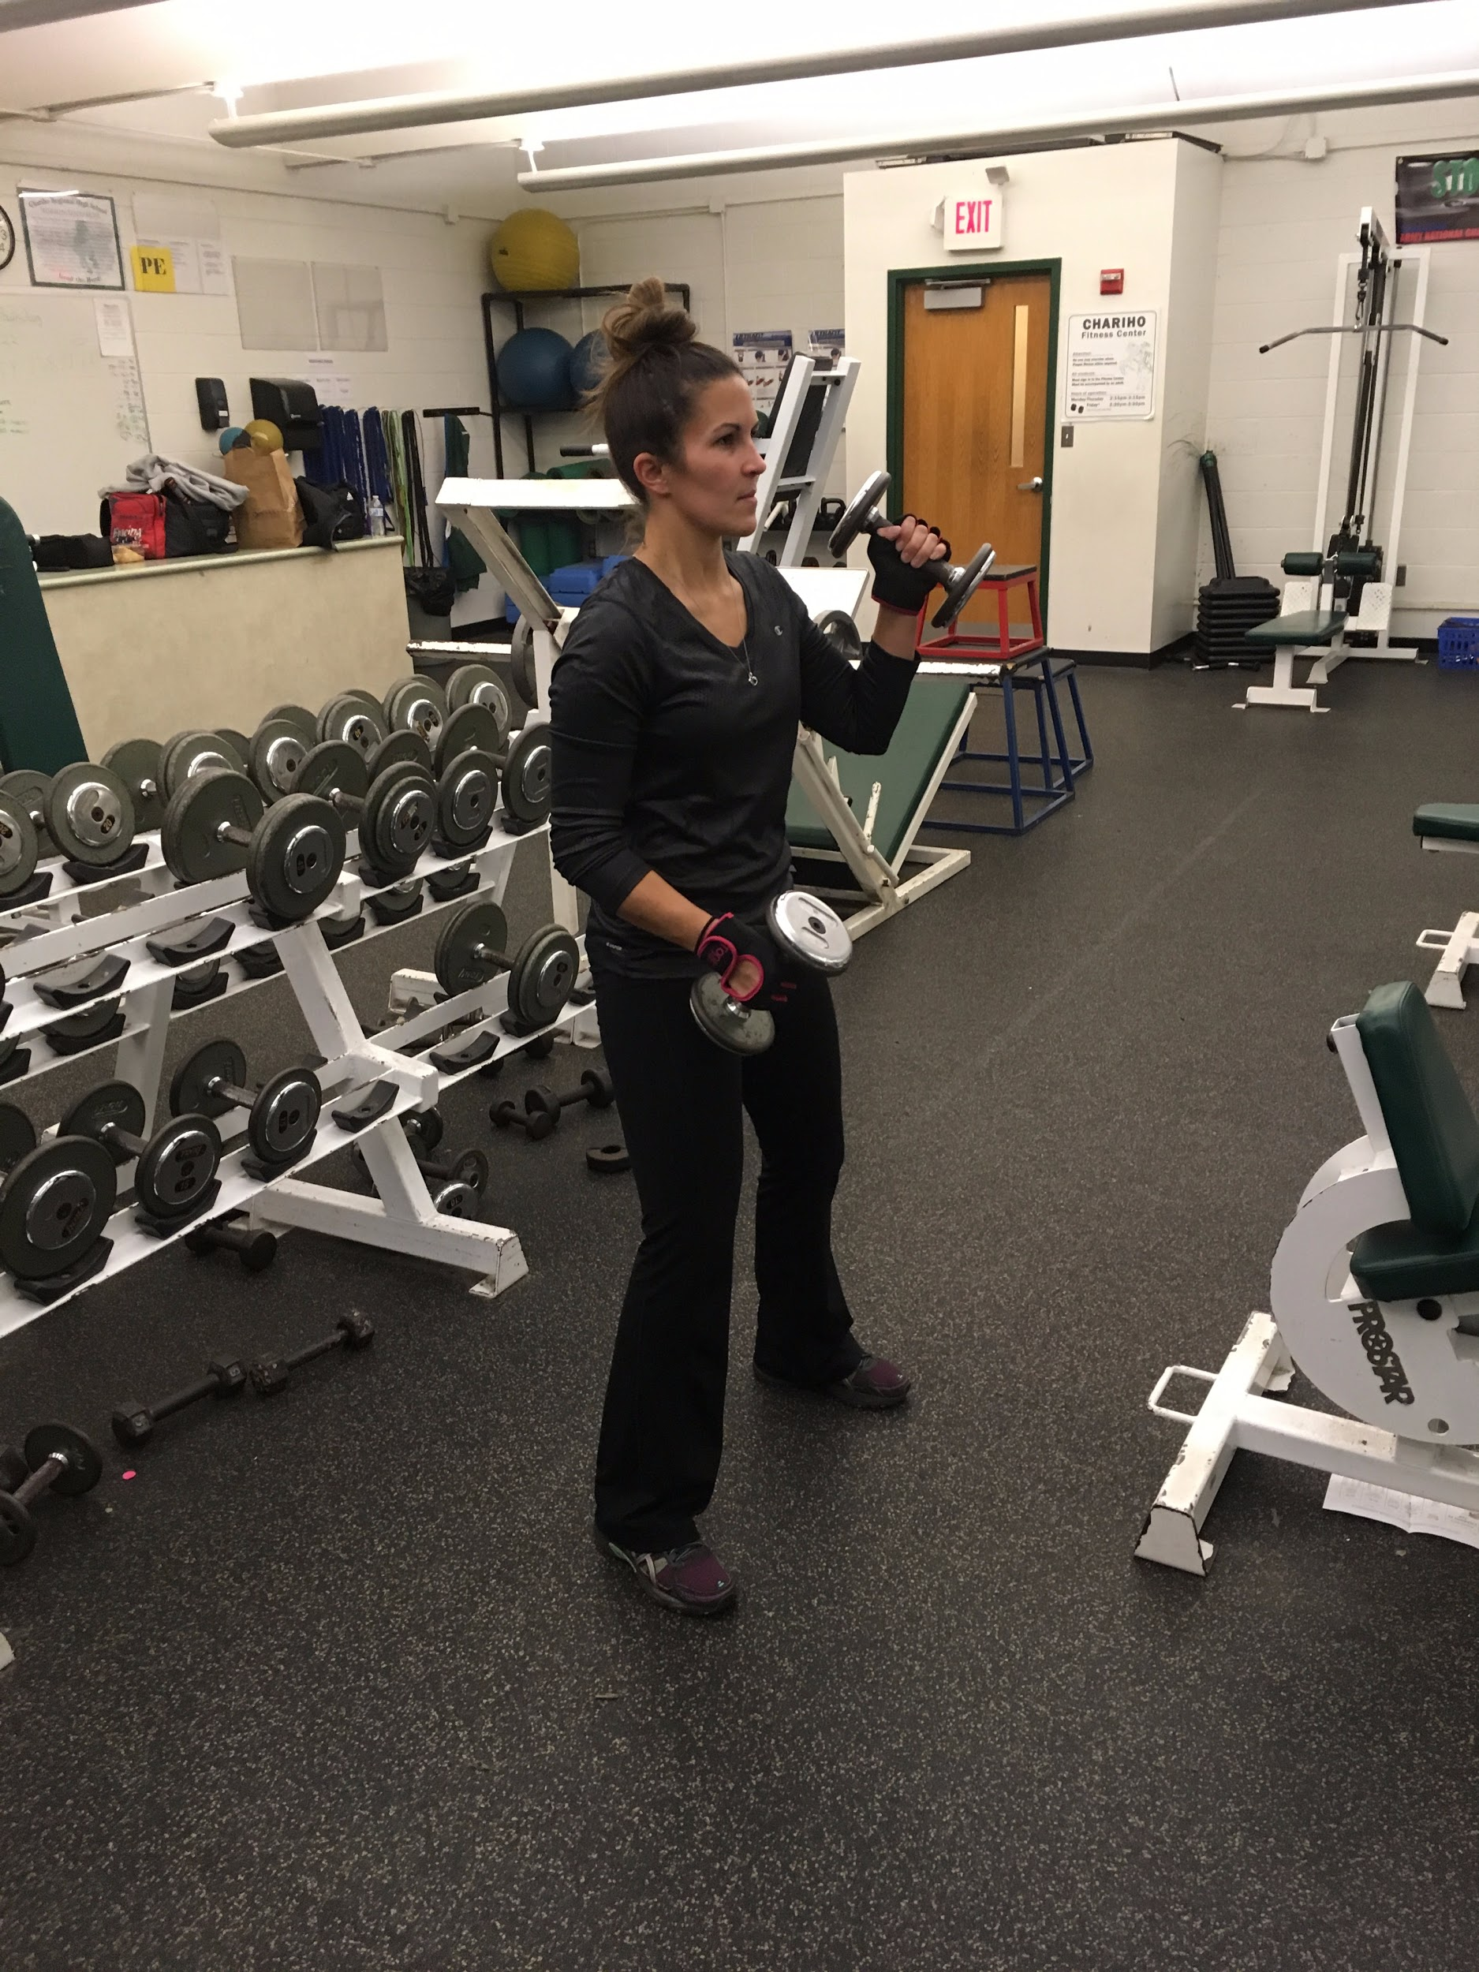
Triceps:
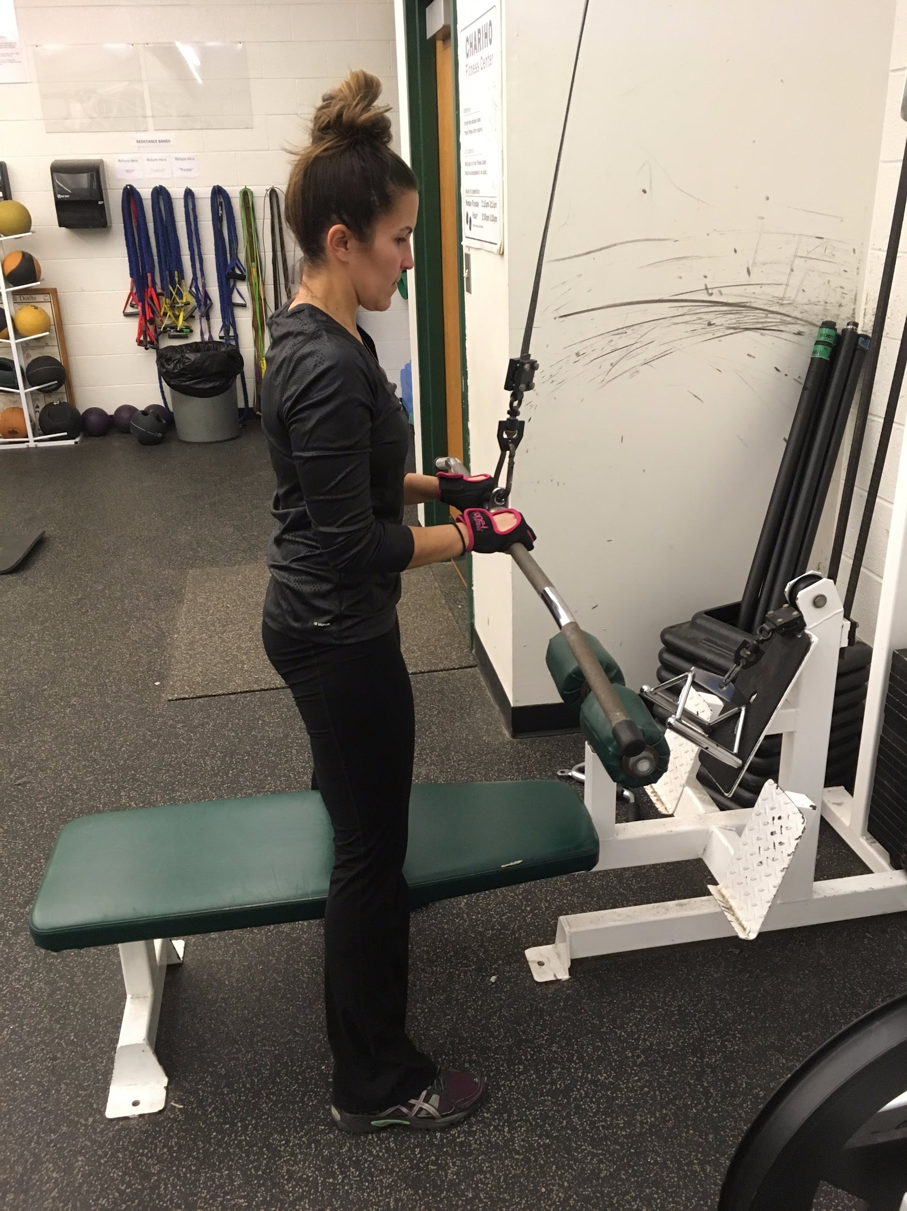or 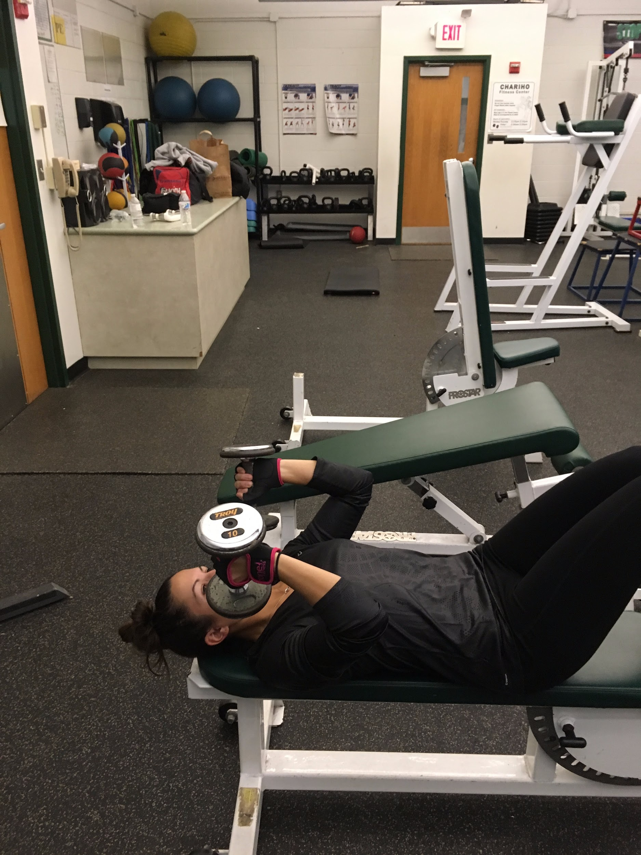

Lats:
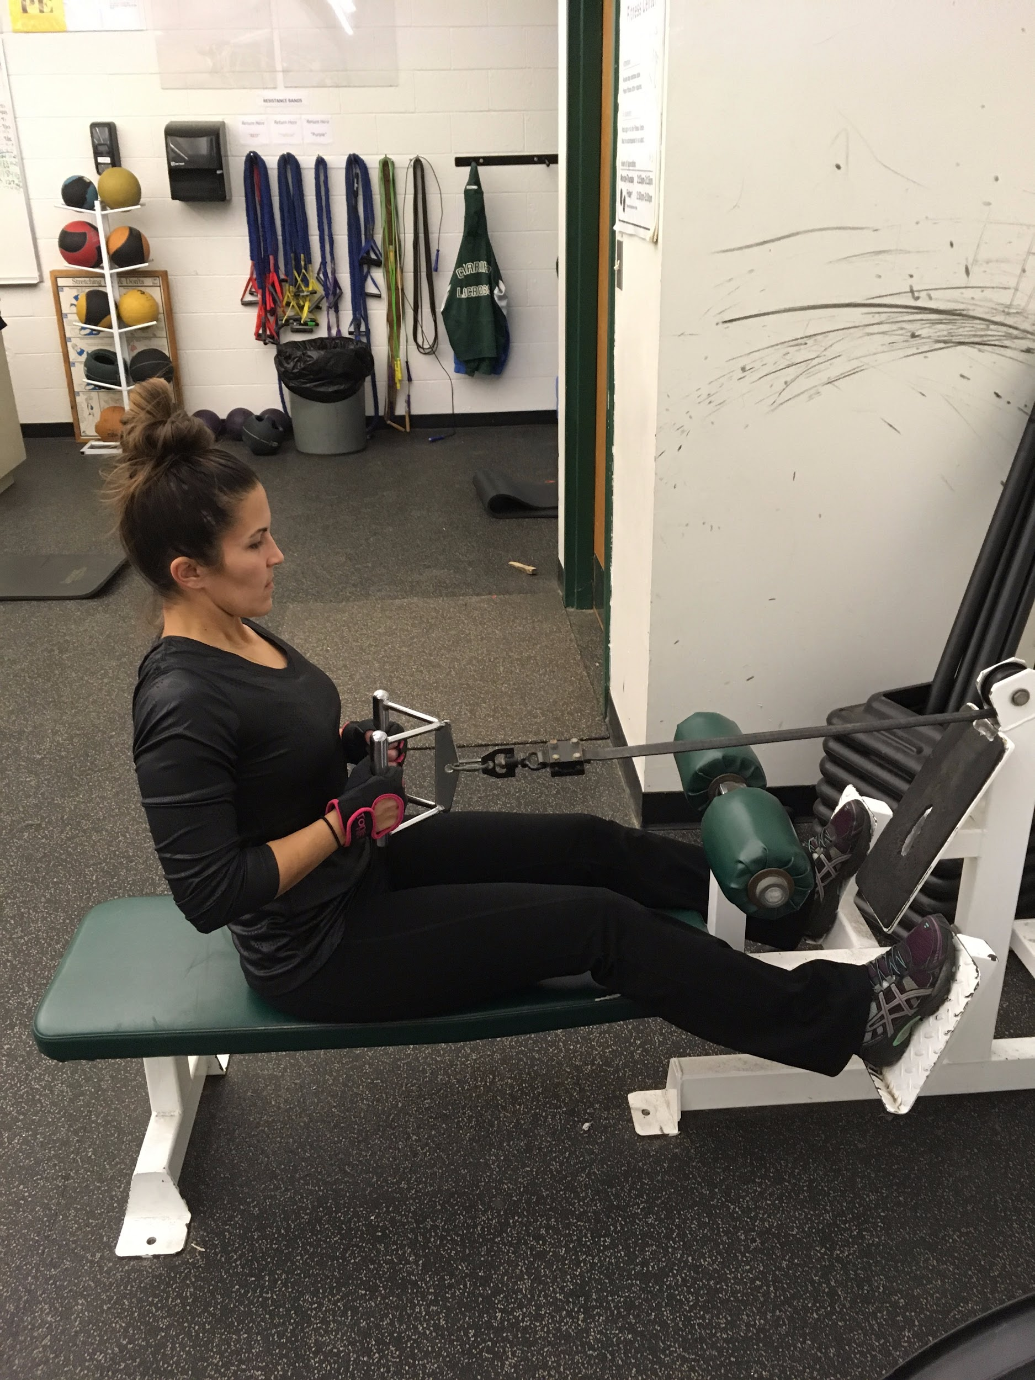or 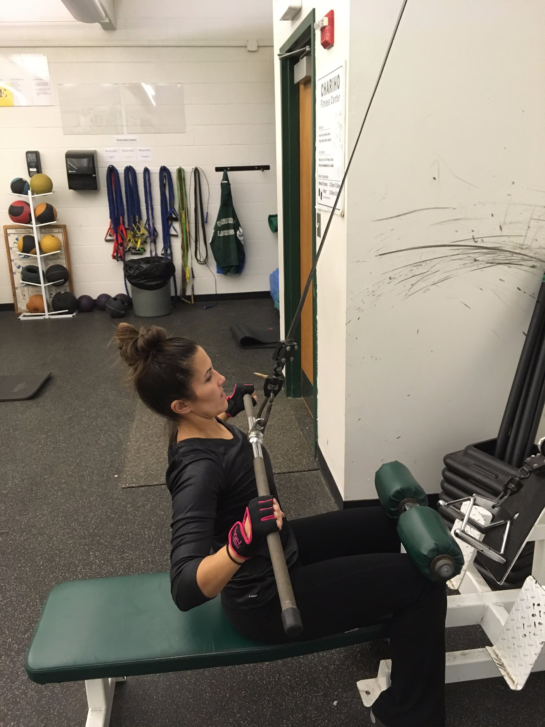
Chest:
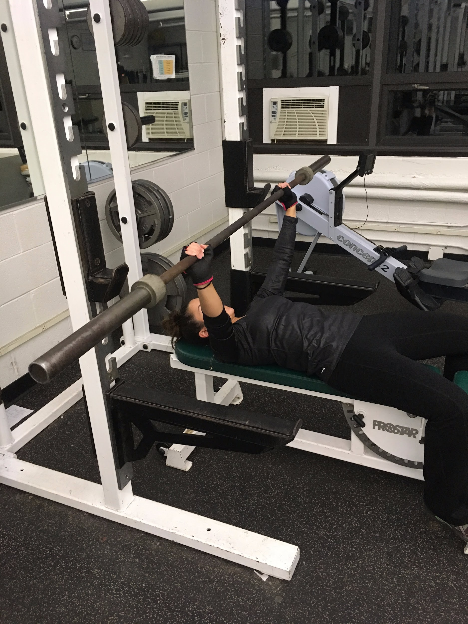or 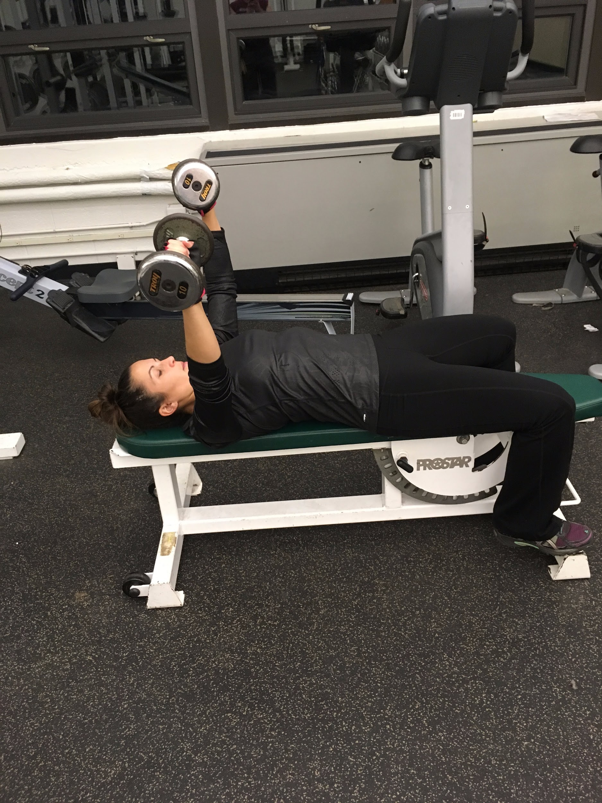
Hamstrings:
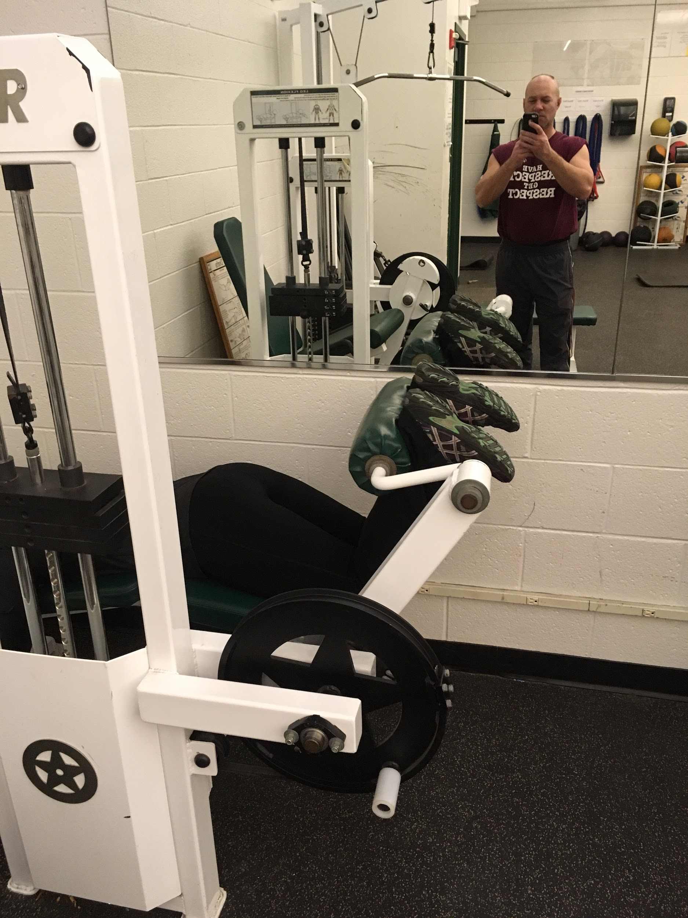or 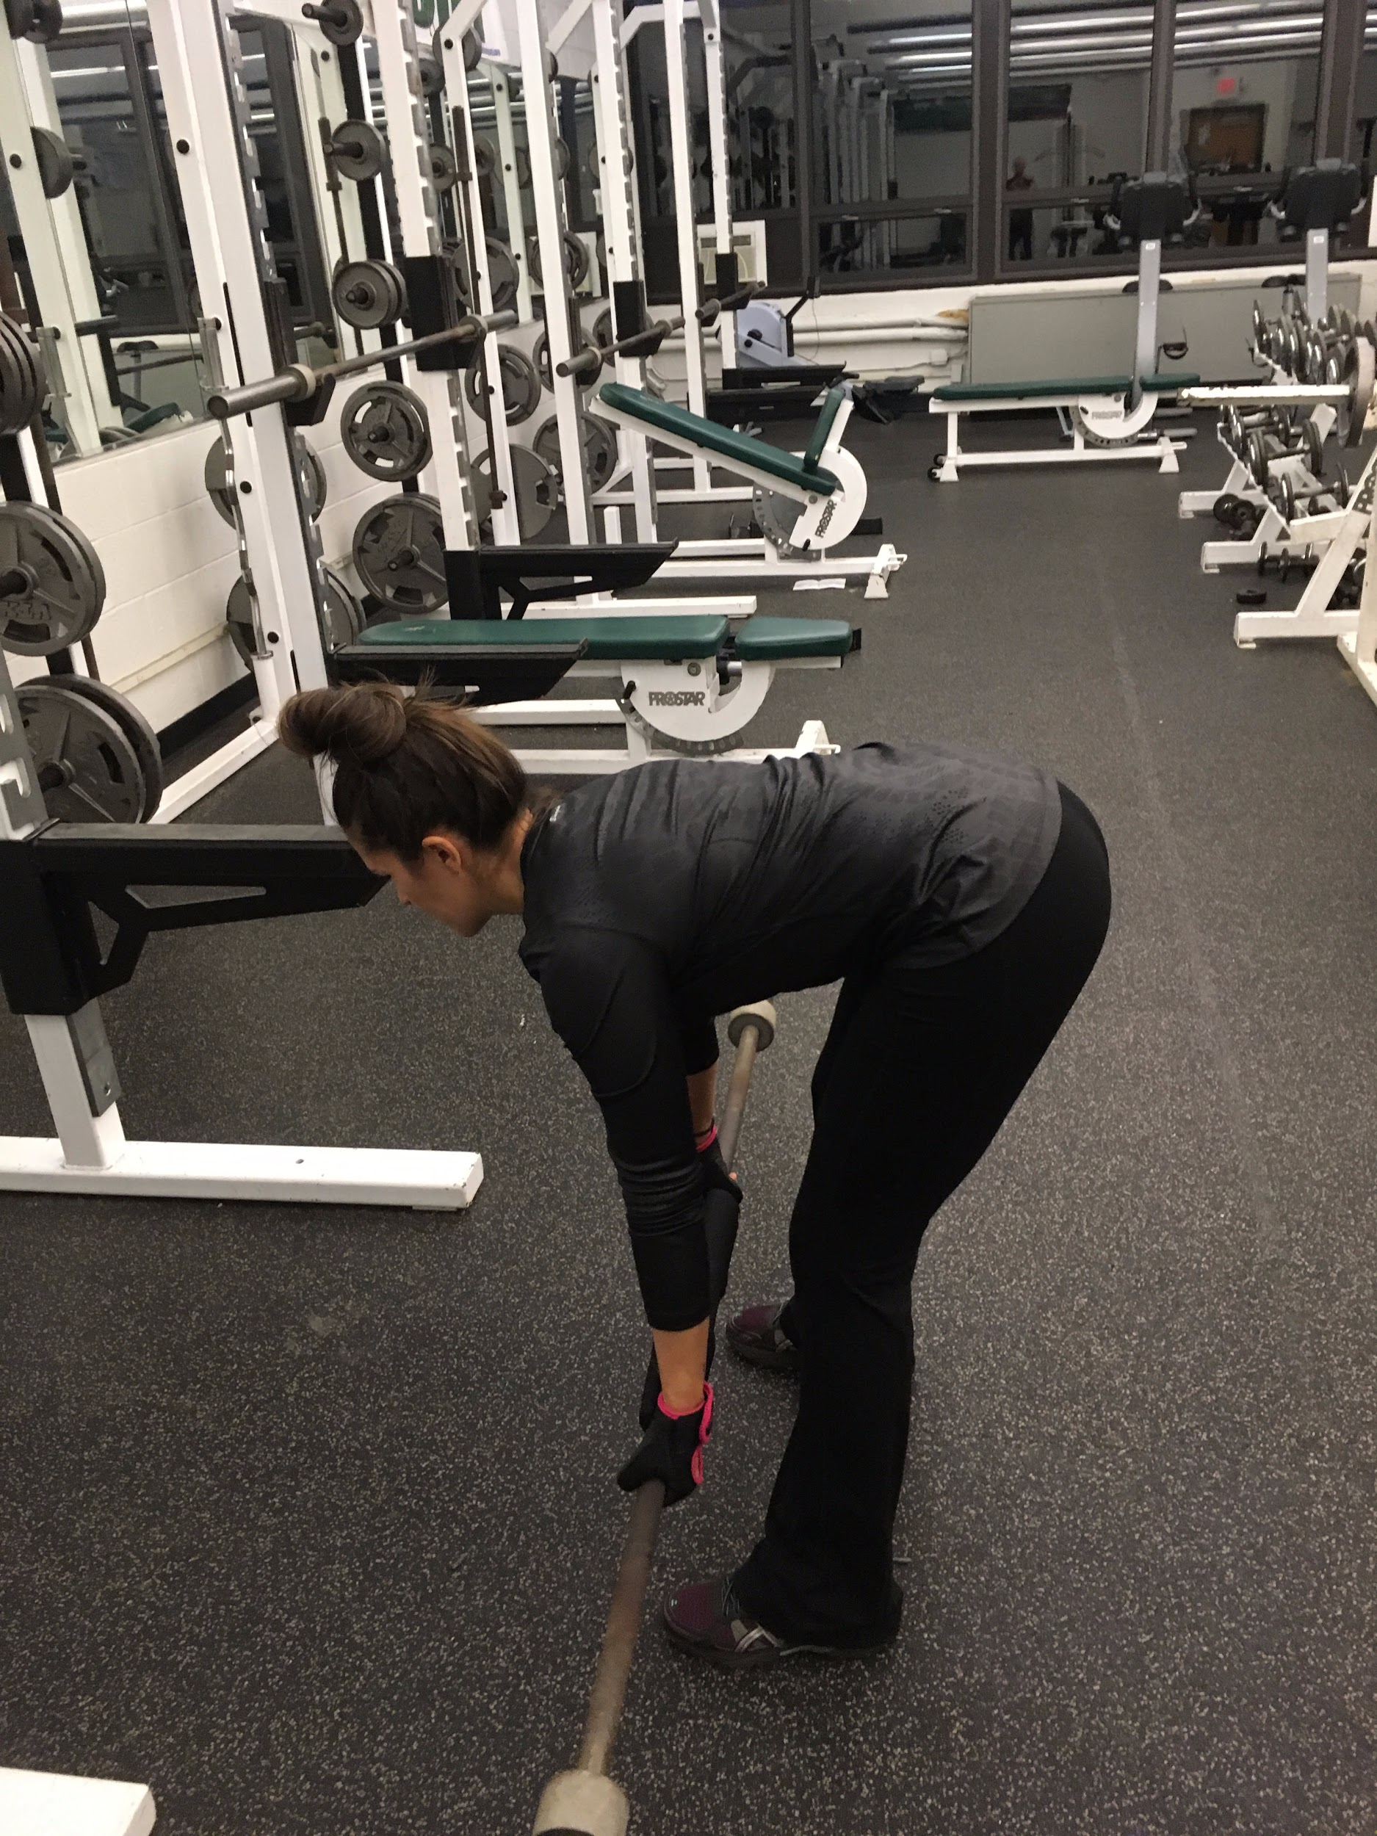
Quads:
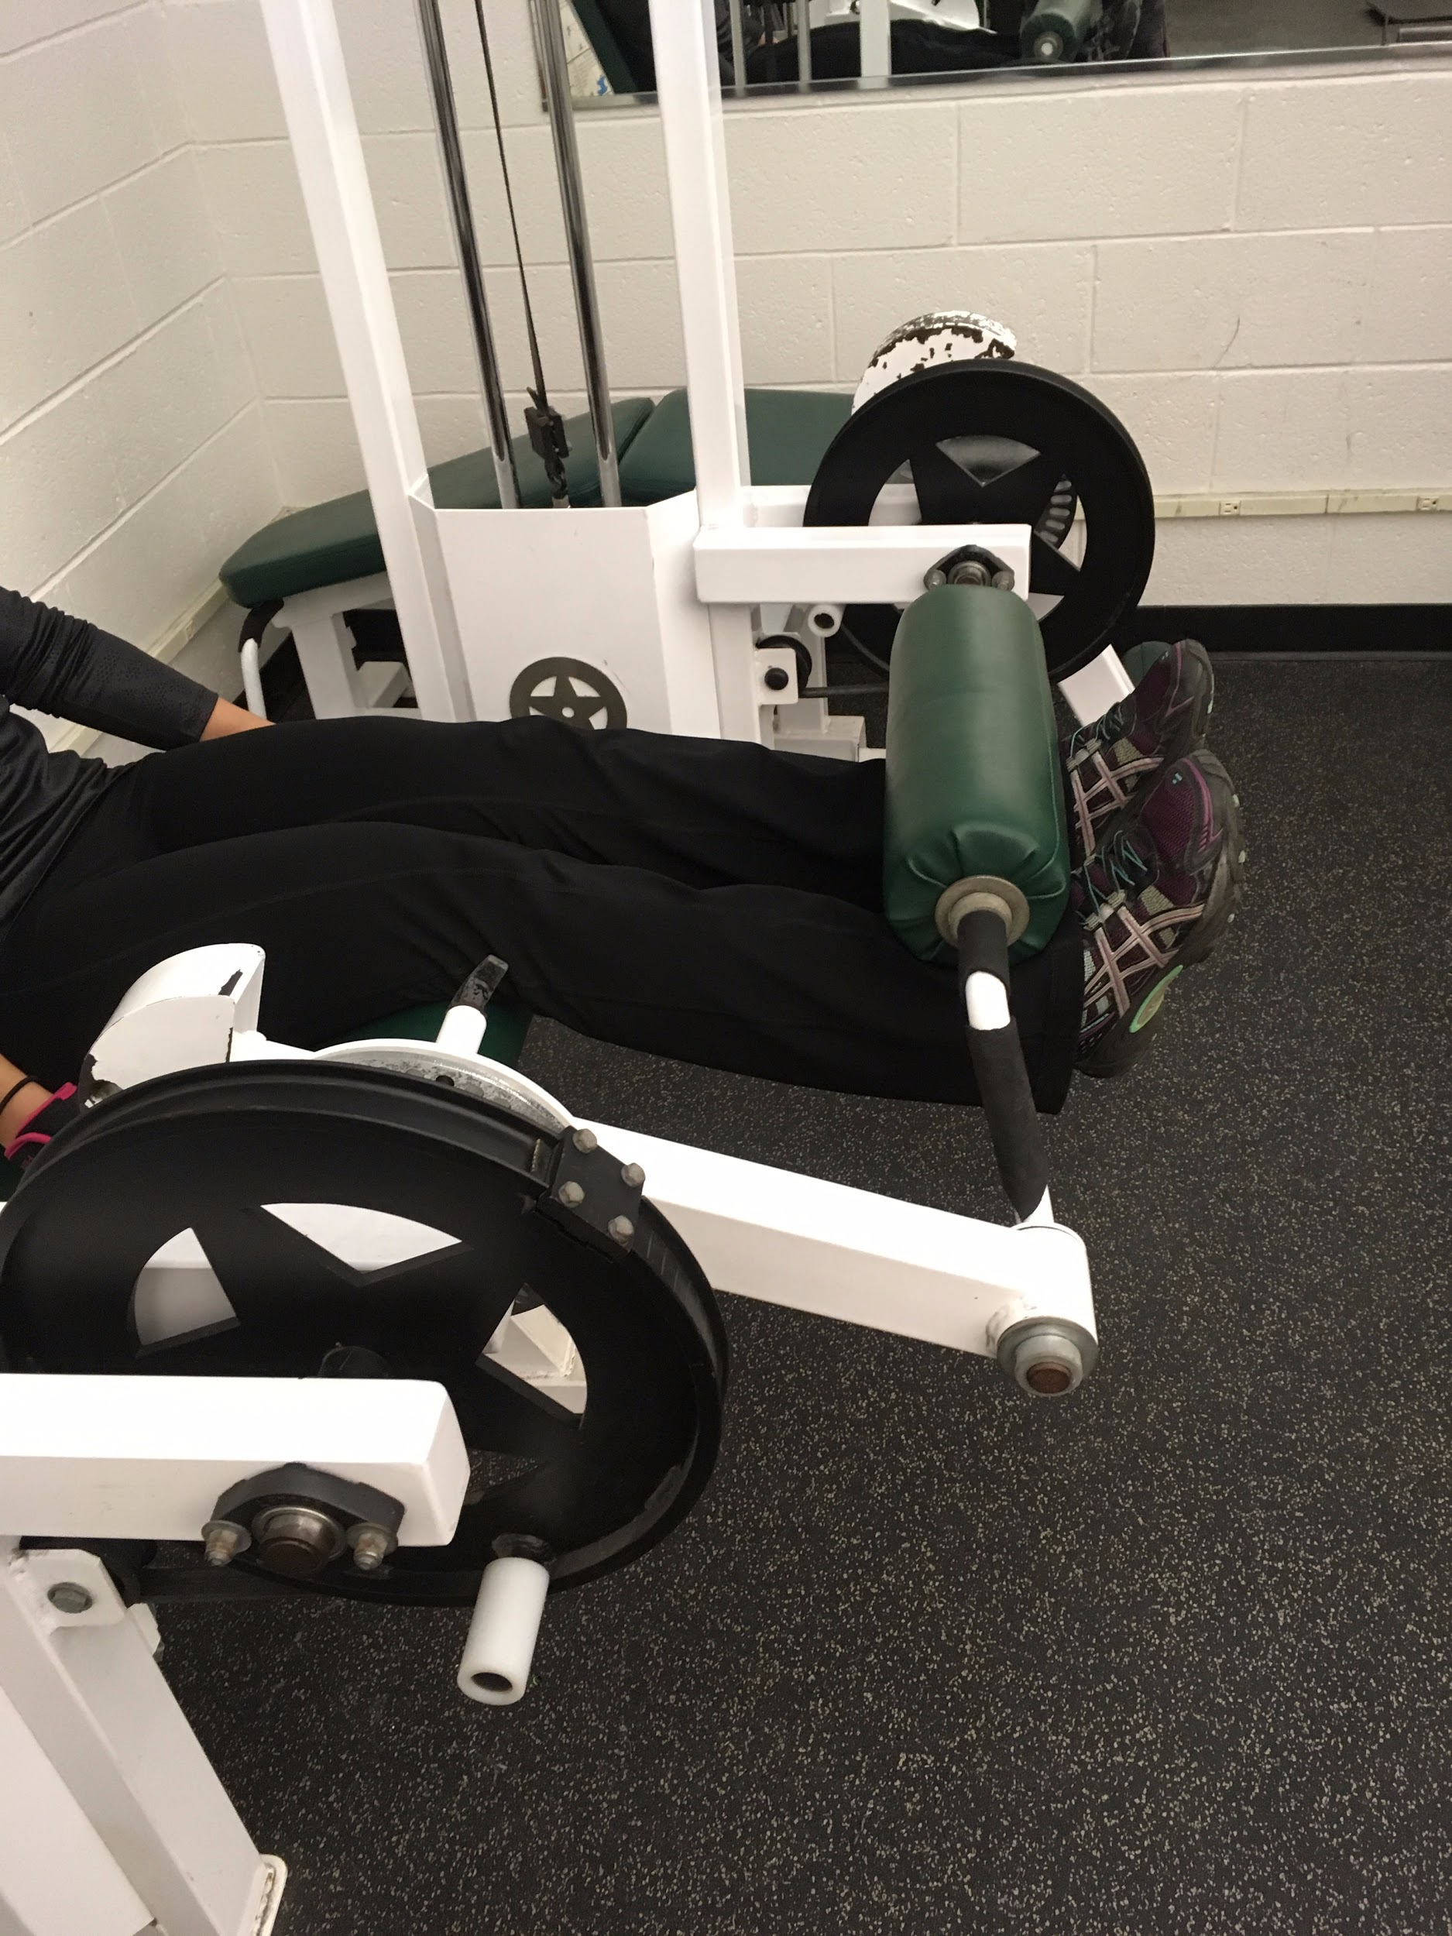or 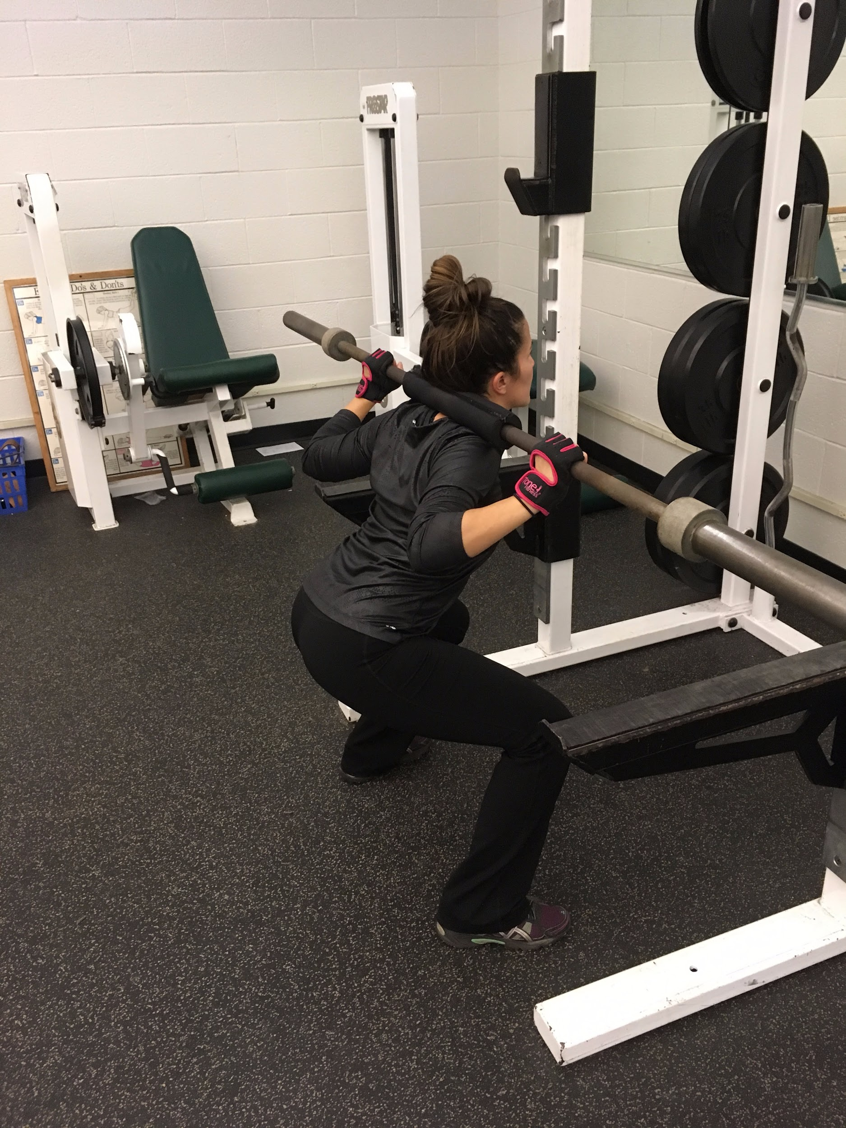

Calfs:
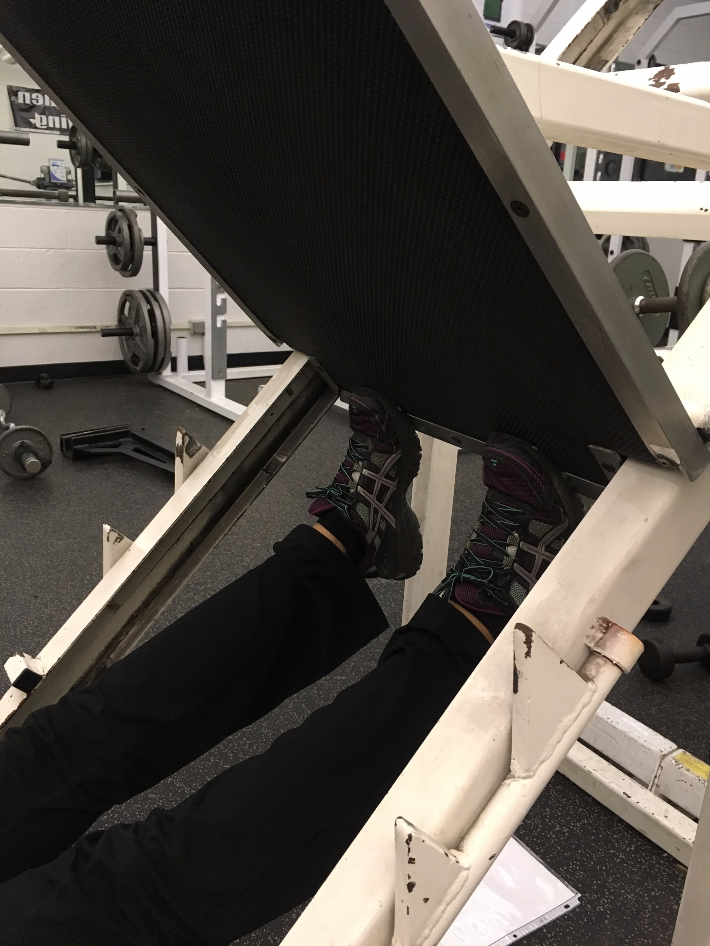or 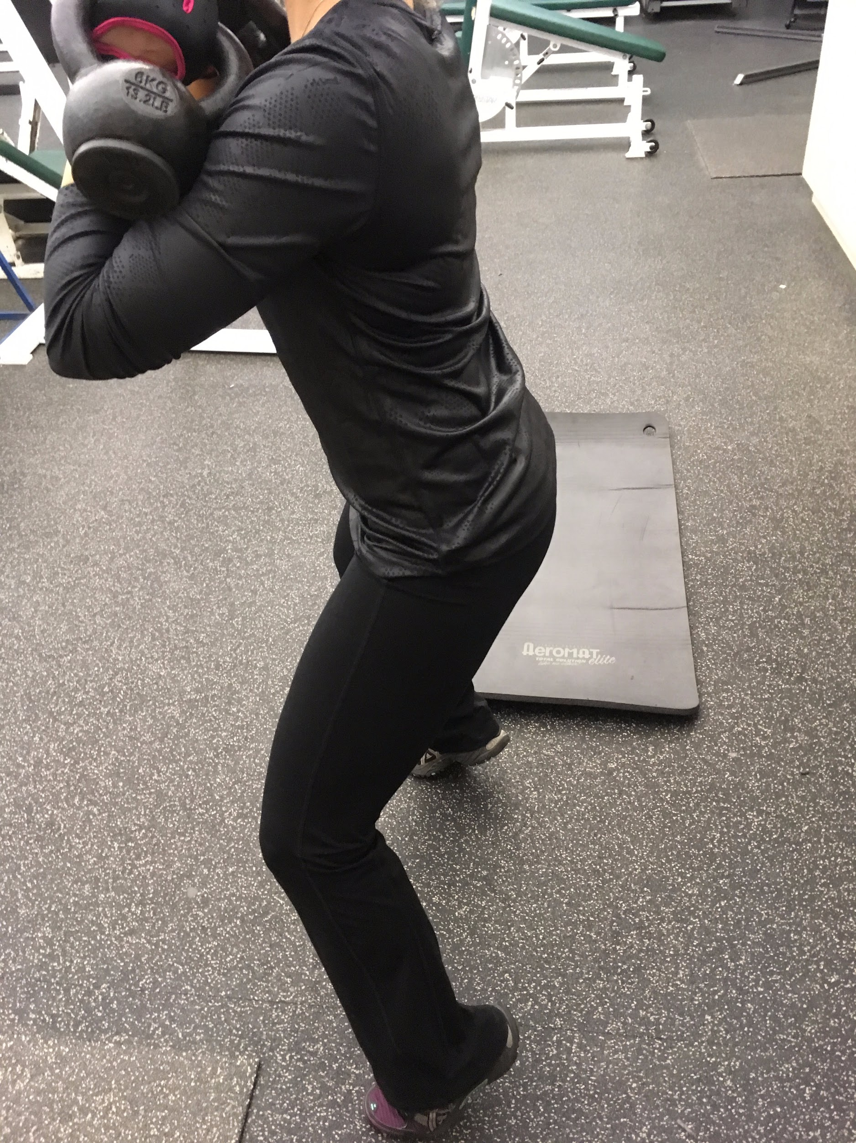
Butt:
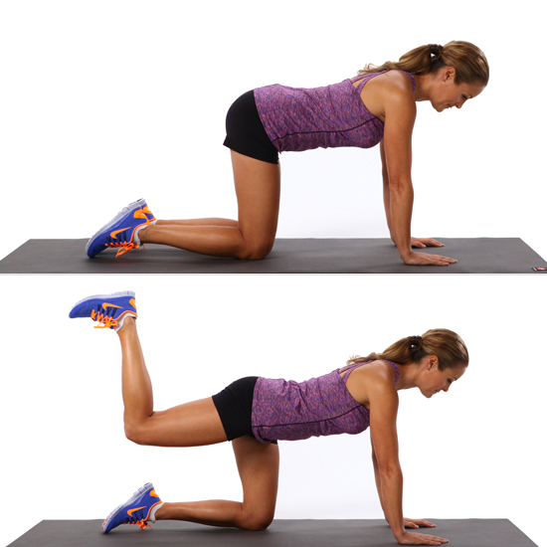or 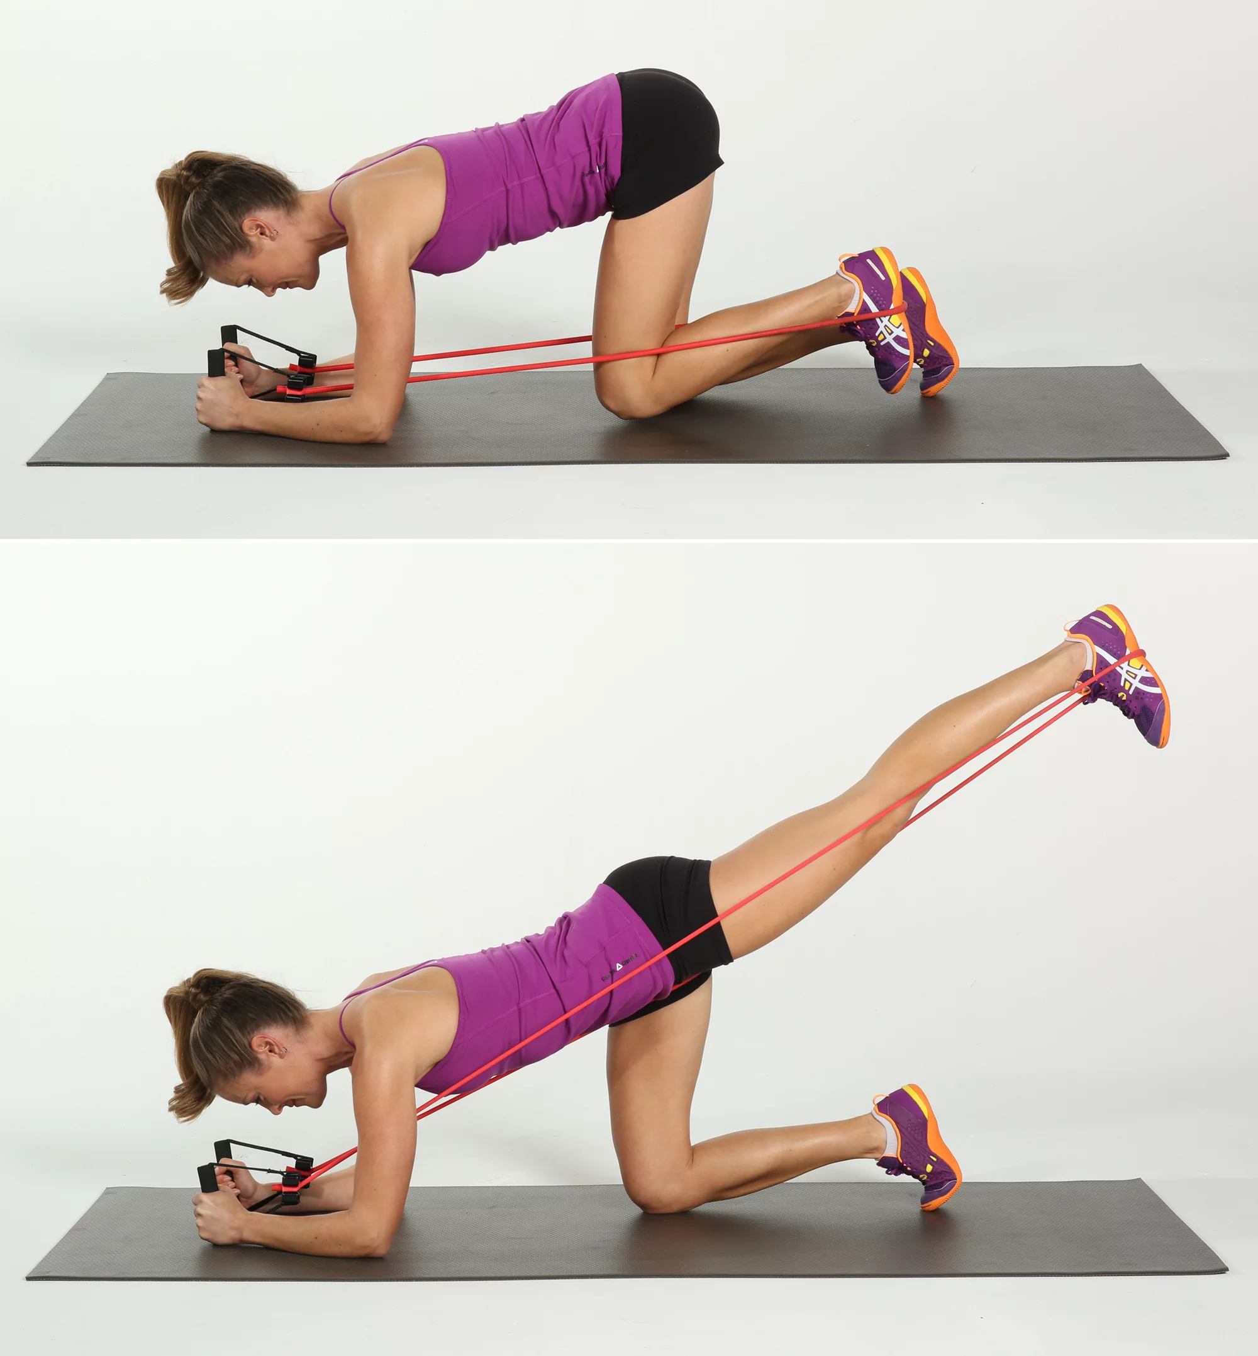

Lower Abs:
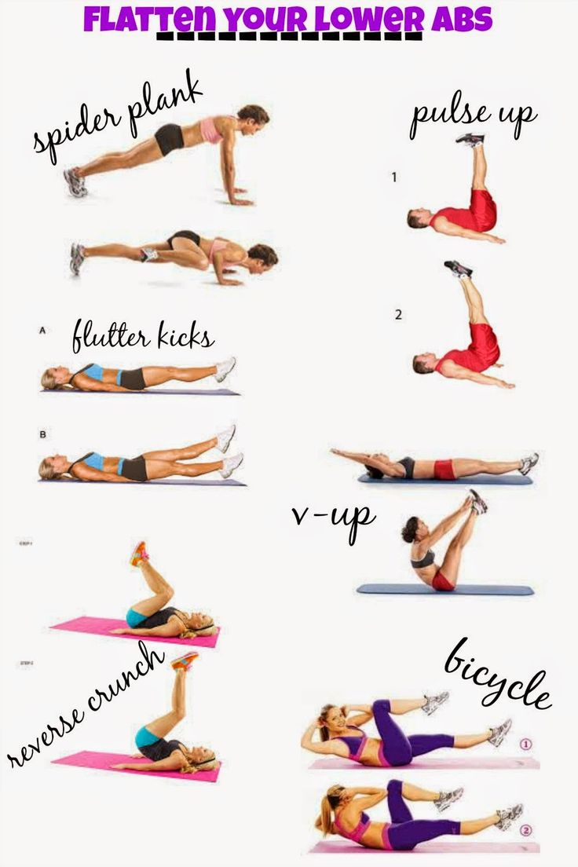
Upper Abs:
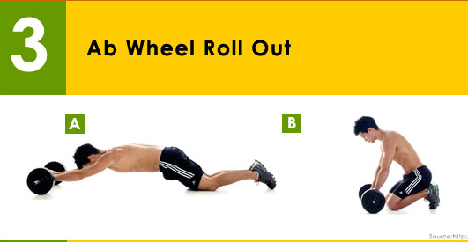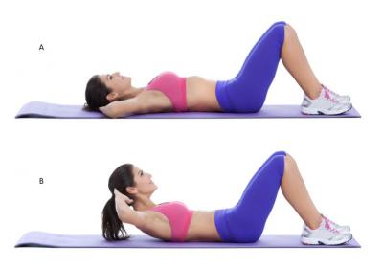
Side Abs:
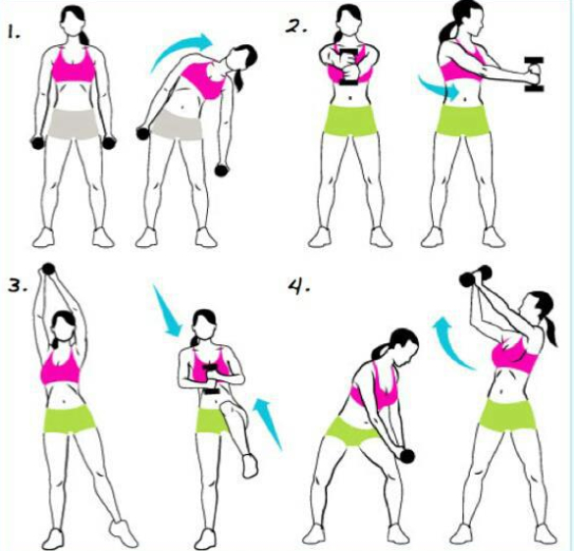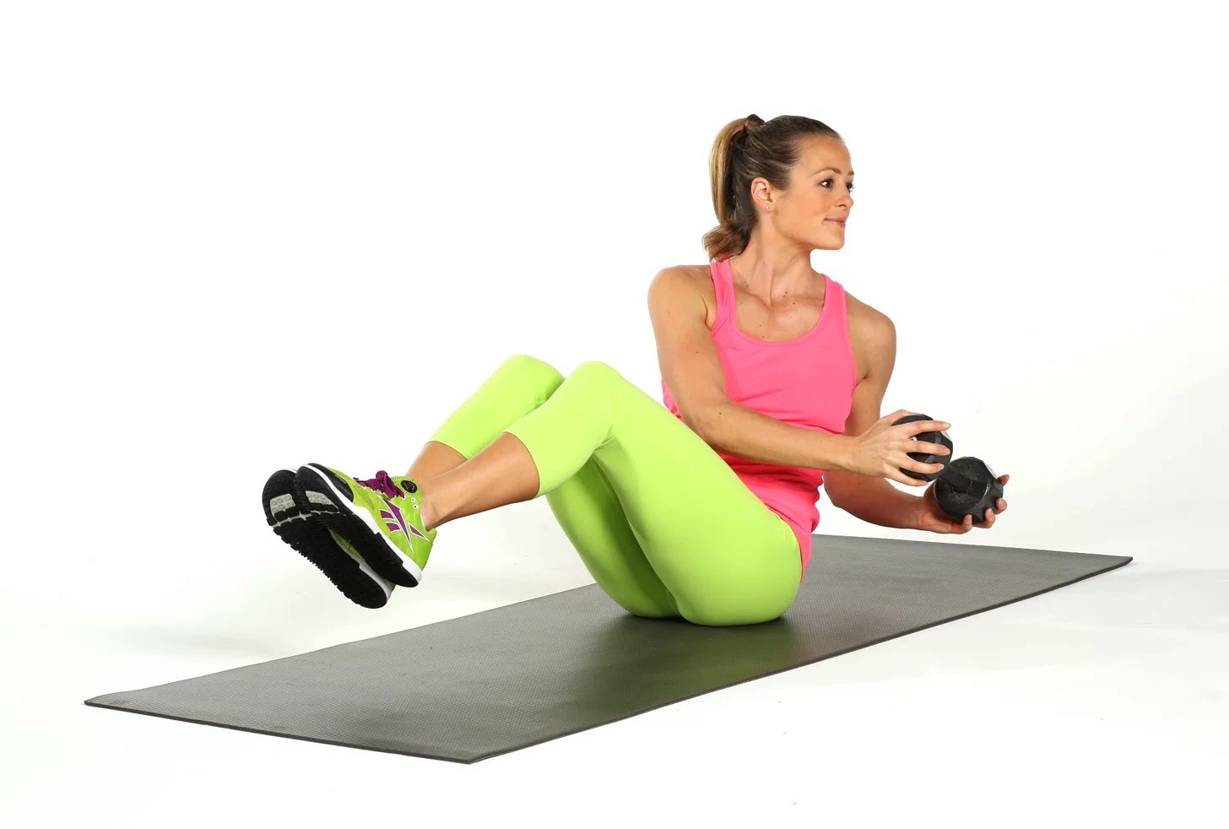
Back:
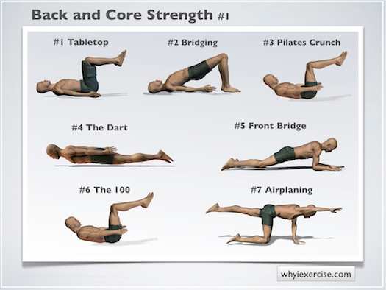or
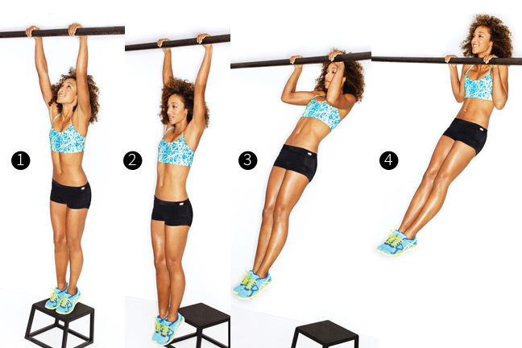

Workout Chart
*Warm-Up Stretch
Set #1

Muscle: | Exercise: | Sets: (3) | Reps: (15) | Weight:
Biceps | Curl bar or  Dumbbell curls | 3
Lower Abs | Spider plank, flutter kicks, reverse crunch, pulse up, V-up, bicycle | 3
Hamstrings | Machine or  Bar dips | 3

Set #2

Muscle: | Exercise: | Sets: (3) | Reps: (15) | Weight:
Triceps | Machine or  Dumbbells | 3
Upper Abs | Ab wheel, crunches | 3
Quads | Machine or  Squats | 3

Set #3

Muscle: | Exercise: | Sets: (3) | Reps: (15) | Weight:
Lats | Machine or  Dumbbells | 3
Side Abs | Standing or V-dumbbell | 3
Calfs | Machine or  Kettlebells | 3

Set #4

Muscle: | Exercise: | Sets: (3) | Reps: (15) | Weight:
Chest | Bar or  Dumbbells | 3
Abs |  | 3
Butt | Donkey kicks or  Band kicks | 3

Set #5

Muscle: | Exercise: | Sets: (3) | Time/Reps: | Weight:
Cardio | Jumping rope, treadmill, bike, elliptical, hallway sprints, or mountain climbers, rower, etc. | 3 | 3-5 min.
Abs |  | 3
Back |  | 3

*Cool-Down Stretch

